* Excel Assignment – 6

1. What are the various elements of the Excel interface? Describe how

they're used.

These are the **menu bar and contain a File, Insert, Page Layout, Formulas, Data, Review, View, Help, and a Search Bar with a light bulb icon**. These menus are divided into subcategories which simplify the distribution of information and analysis of calculations.

2. Write down the various applications of Excel in the industry.

Microsoft Excel enables users to **identify trends and organize and sort data into meaningful categories**. Excel also performs Human Resources functions, such as sorting worked hours and organizing employee profiles and expenses, which help businesses better understand the structure and activities of their workforce.

3. On the ribbon, make a new tab. Add some different groups, insert

commands in the groups and name them according to their command

added. Copy and paste the screenshot of the steps you followed.

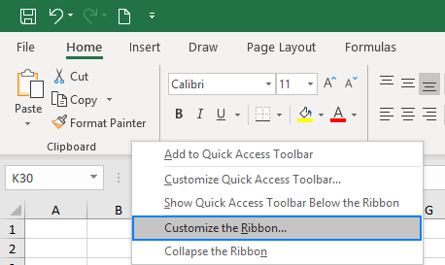

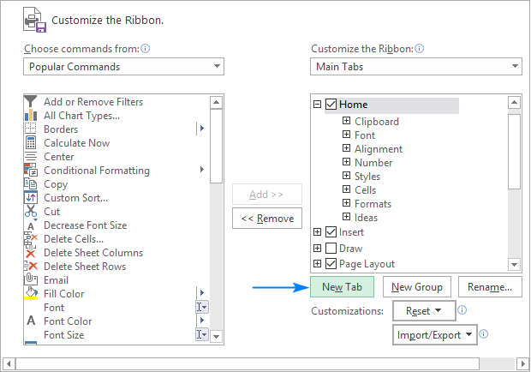

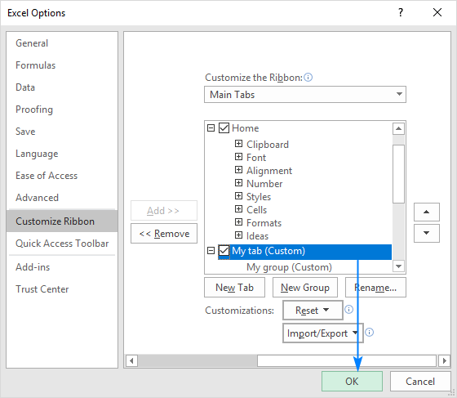

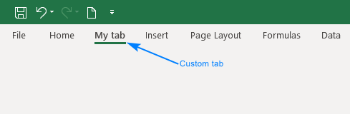

4. Make a list of different shortcut keys that are only connected to

formatting with their functions.

Ctrl+C → Copy selected text or graphics to the Office Clipboard. Ctrl+V → Paste the most recent addition to the Office Clipboard. Ctrl+Shift+A → Format all letters as capitals. Ctrl+B → Applies or removes bold formatting.

5. What distinguishes Excel from other analytical tools?

**it provides different color shades, font types to format the spreadsheet and differentiate between rows and columns**. It is good to present useful presenting information such as balance, tax profit etc

6. Create a table and add a custom header and footer to your table.

1. Click the worksheet where you want to add or change headers or footers.
2. On the **Insert** tab, in the **Text** group, click **Header & Footer**.

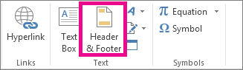

Excel displays the worksheet in **Page Layout** view.

1. To add or edit a header or footer, click the left, center, or right header or footer text box at the top or the bottom of the worksheet page (under **Header**, or above **Footer**).
2. Type the new header or footer text.